The preferred browser for Cognos 10.2 is Internet Explorer version 8 or 9.
Configuring Internet Explorer (IE) for Cognos – Pop up Blocker and allow downloads of Excel or PDF files.
Step 1 – Pop up Blocker
Open IE, click on “Tools” from the menu bar. Click on “Pop up Blocker”, and then click “Pop up Blocker Settings”.

Click on Tools, Pop up Blocker and Pop up Blocker Settings

A new Pop up Blocker Setting box will open. Review the Allowed sites in the middle of the box.
3. Click Add after typing cognos.udel.edu
2. If missing type Cognos.udel.edu in this box

Review list of Allowed sites.
4. Click Close when finished

If cognos.udel.edu is not in the box, click in the empty box under Address of website to allow. Type cognos.udel.edu and click “Add” on the right side. Click “Close” at the bottom of the Pop up Blocker Settings box.

Step 2 – Downloads
Open IE, click on “Tools” from the menu bar. At the bottom of the menu box, select Internet Options.
Click Tools

Click Internet Options

Step 2 – Downloads Continued
An Internet Options box will open. Select the 2nd tab “Security”. Click on the Internet icon, and then click “Custom level” near the bottom of the box. The Security Settings – Internet Zone box will open. Using the scroll bar on the side of the box, scroll down the options to “Downloads”. There are three options: Automatic prompting for the file downloads, File download and Font download. Make sure the bullet (green circle) is Enable for each option, click OK. You will return to the “Security” tab of the Internet Options box.
The Security Settings window will open after clicking Custom level.
- Click on the Security tab
2. Click on the Internet icon

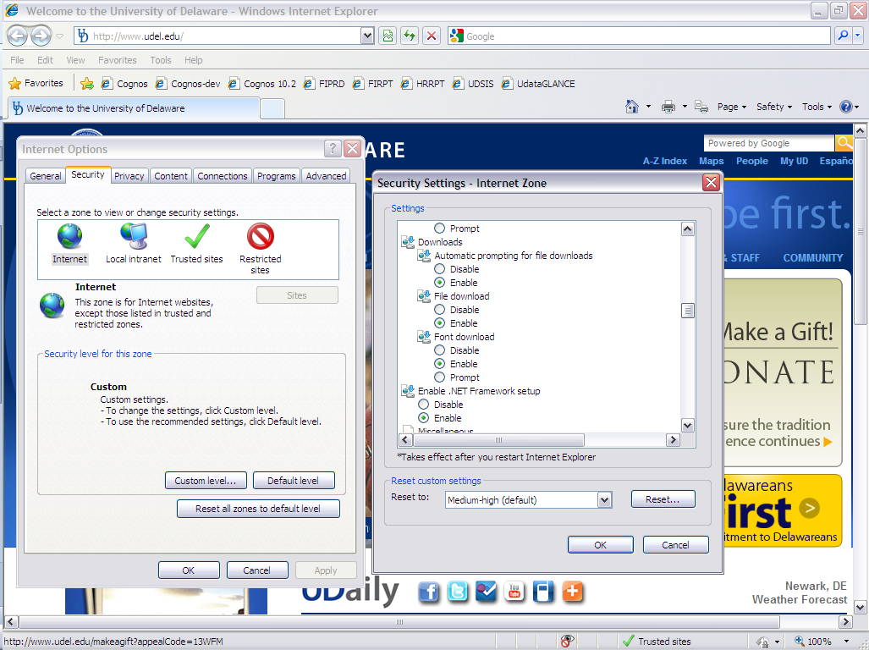
5. Enable all three
4. Scroll to Downloads
3. Click on Custom level
6. Click OK

Step 2 – Downloads Continued
Click on the “Local intranet” icon, and then click “Custom level” near the bottom of the box. The Security Settings – Local Internet Zone box will open. Using the scroll bar on the side of the box, scroll down the options to “Downloads”. There are three options: Automatic prompting for the file downloads, File download and Font download. Make sure the bullet (green circle) is Enable for each option, click OK. You will return to the “Security” tab of the Internet Options box.

The Security Settings window will open after clicking Custom level.
- Click on the Local Internet icon

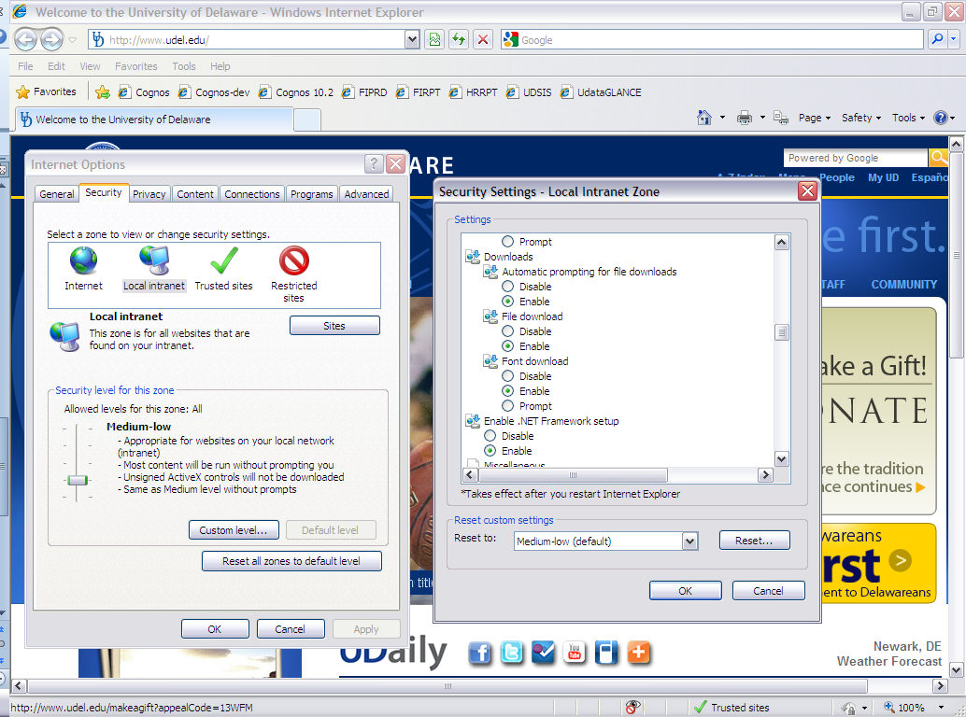
3.Scroll to Downloads
4. Enable all three
5. Click OK
2. Click on Custom level

Step 2 – Downloads Continued
Click on the “Trusted sites” icon, and then click “Custom level” near the bottom of the box. The Security Settings – Trusted Sites Zone box will open. Using the scroll bar on the side of the box, scroll down the options to “Downloads”. There are three options: Automatic prompting for the file downloads, File download and Font download. Make sure the bullet (green circle) is Enable for each option, click OK. You will return to the “Security” tab of the Internet Options box. Click OK at the bottom of the “Security” tab.

The Security Settings window will open after clicking Custom level.
- Click on the Trusted Sites icon

6. Click OK
3.Scroll to Downloads
5. Click OK
2. Click on Custom level
4. Enable all three

